**DAY – 5**

**TASK 1:**

package com.DAY5;

import org.openqa.selenium.By;

import org.openqa.selenium.WebDriver;

import org.openqa.selenium.WebElement;

import org.openqa.selenium.chrome.ChromeDriver;

import org.openqa.selenium.chrome.ChromeOptions;

import org.openqa.selenium.interactions.Actions;

import io.github.bonigarcia.wdm.WebDriverManager;

public class Task1 {

public static void main(String[]args) {

WebDriverManager.chromedriver().setup();

ChromeOptions co=new ChromeOptions();

co.addArguments("--remote-allow-origins=*");

WebDriver driver=new ChromeDriver(co);

driver.get("https://demoqa.com/droppable/");

Actions a = new Actions(driver);

WebElement sourceEle= driver.findElement(By.id("draggable"));

WebElement destEle = driver.findElement(By.id("droppable"));

a.clickAndHold(sourceEle).release(destEle).build().perform();

a.dragAndDrop(sourceEle, destEle).build().perform();

}

}

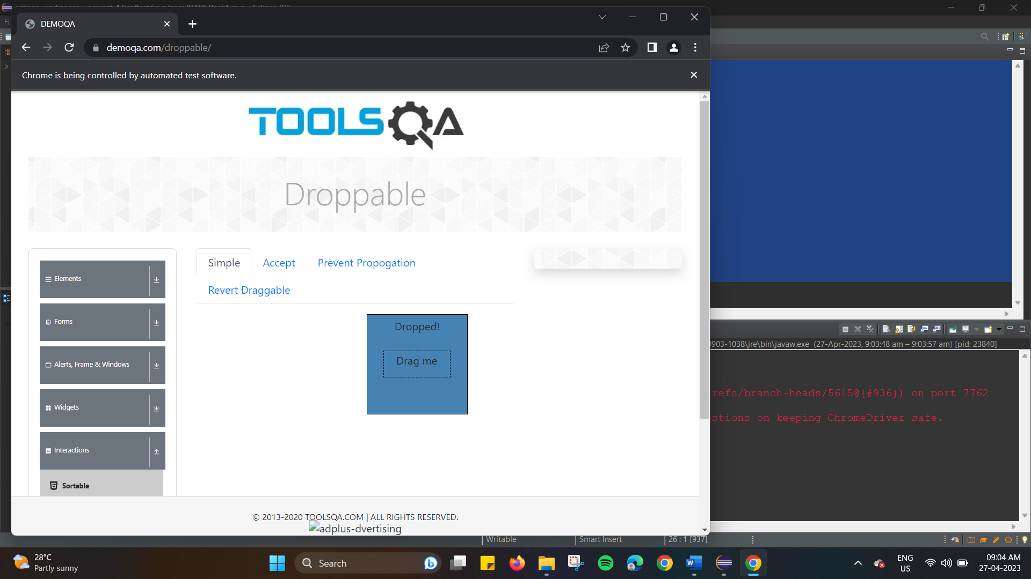

**TASK 2 :**

package com.DAY5;

import org.openqa.selenium.By;

import org.openqa.selenium.WebDriver;

import org.openqa.selenium.WebElement;

import org.openqa.selenium.chrome.ChromeDriver;

import org.openqa.selenium.chrome.ChromeOptions;

import org.openqa.selenium.interactions.Actions;

import io.github.bonigarcia.wdm.WebDriverManager;

public class Task2 {

public static void main(String[]args) throws InterruptedException {

WebDriverManager.chromedriver().setup();

ChromeOptions co=new ChromeOptions();

co.addArguments("--remote-allow-origins=*");

WebDriver driver=new ChromeDriver(co);

driver.get("https://jqueryui.com/droppable/");

driver.switchTo().frame(0);

Actions a = new Actions(driver);

WebElement sourceEle= driver.findElement(By.id("draggable"));

WebElement destEle = driver.findElement(By.id("droppable"));

Thread.sleep(3000);

a.clickAndHold(sourceEle).release(destEle).build().perform();

a.dragAndDrop(sourceEle, destEle).build().perform();

}

}

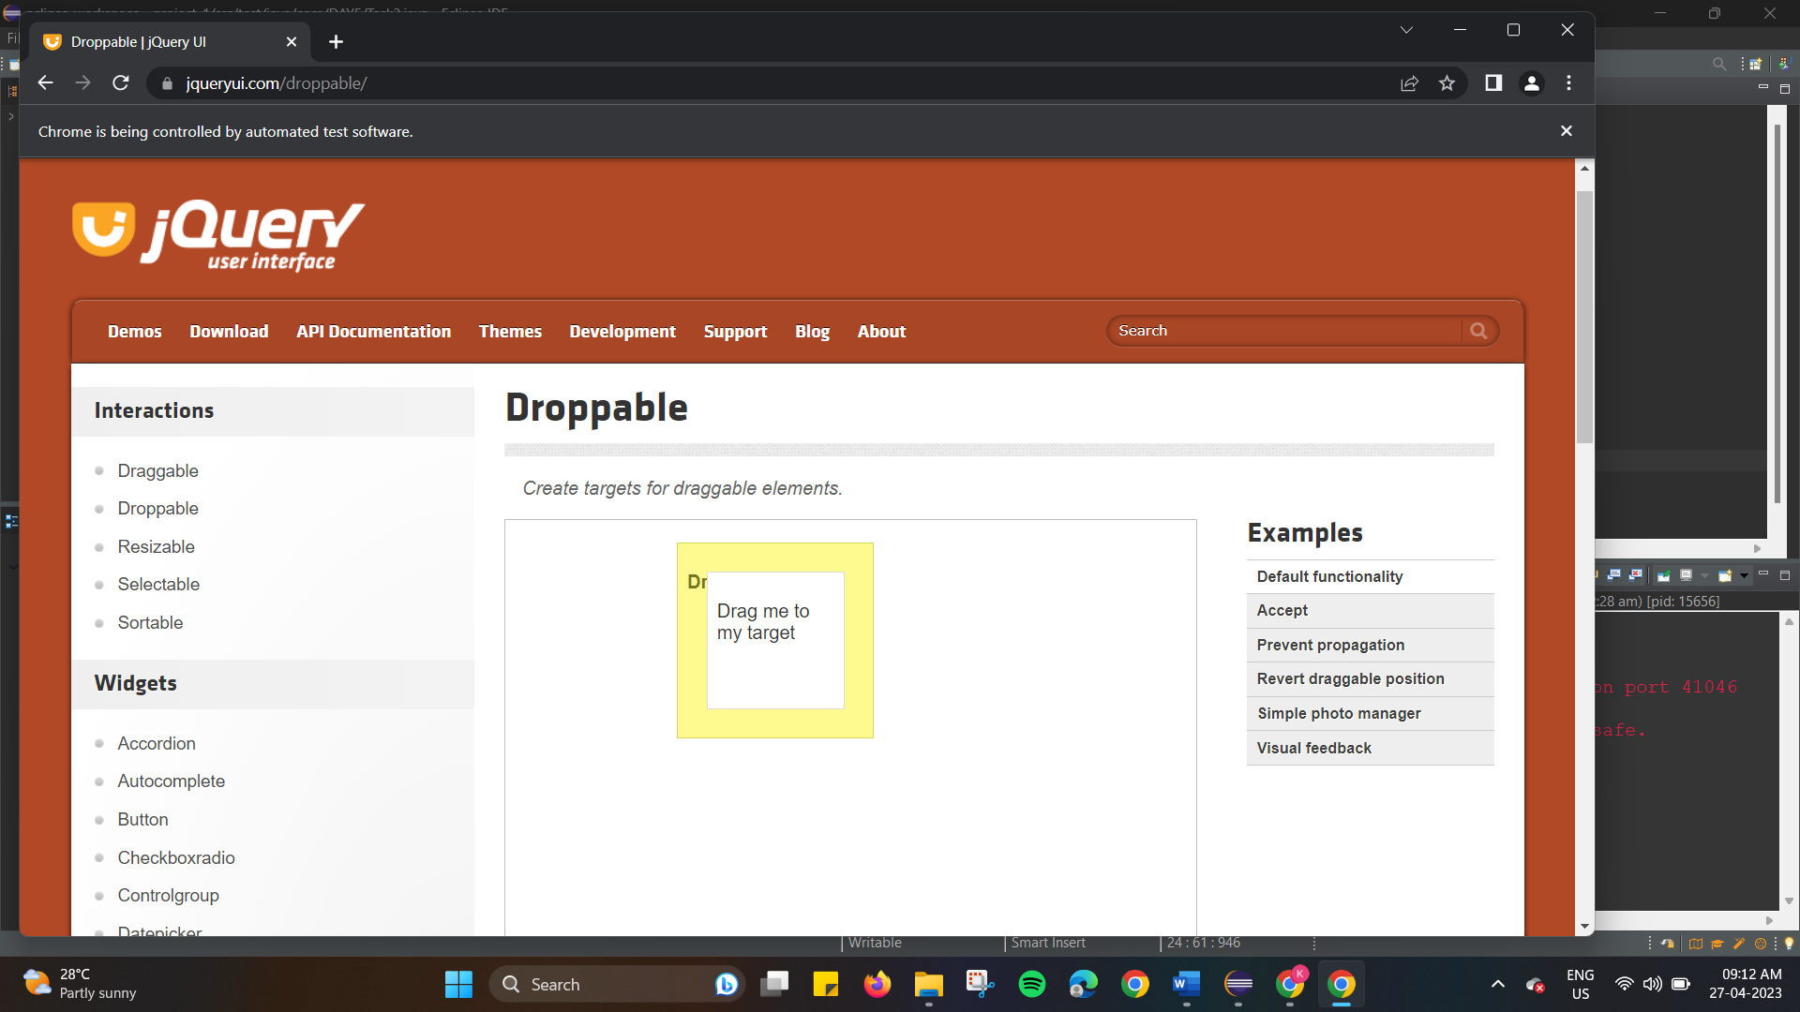

**TASK 3 :**

package com.DAY5;

import org.openqa.selenium.Alert;

import org.openqa.selenium.By;

import org.openqa.selenium.WebDriver;

import org.openqa.selenium.WebElement;

import org.openqa.selenium.chrome.ChromeDriver;

import org.openqa.selenium.chrome.ChromeOptions;

import io.github.bonigarcia.wdm.WebDriverManager;

public class Task3 {

public static void main(String[]args) throws InterruptedException {

WebDriverManager.chromedriver().setup();

ChromeOptions co=new ChromeOptions();

co.addArguments("--remote-allow-origins=*");

WebDriver driver=new ChromeDriver(co);

driver.get("https://demo.guru99.com/test/delete_customer.php");

WebElement textBox=driver.findElement(By.name("cusid"));

WebElement submitButton = driver.findElement(By.name("submit"));

textBox.sendKeys("401");

submitButton.click();

Alert alert1 = driver.switchTo().alert();

alert1.dismiss();

textBox.clear();

textBox.sendKeys("402");

submitButton.click();

Alert alert2 = driver.switchTo().alert();

alert2.accept();

Alert alert3 = driver.switchTo().alert();

String text = alert3.getText();

alert3.accept();

System.out.println(text);

}

}

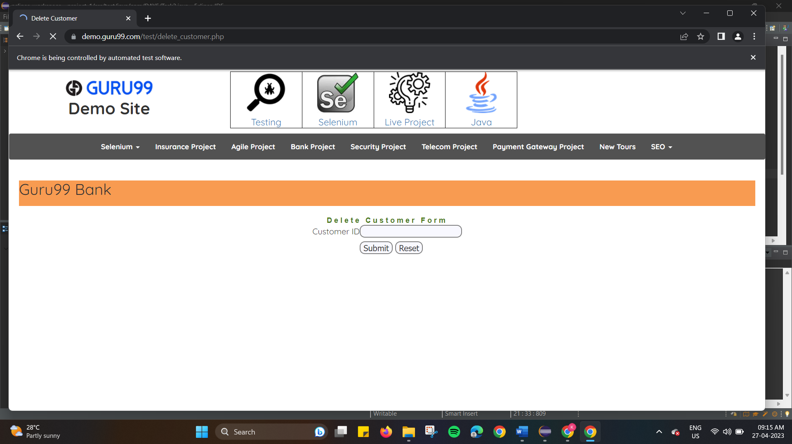

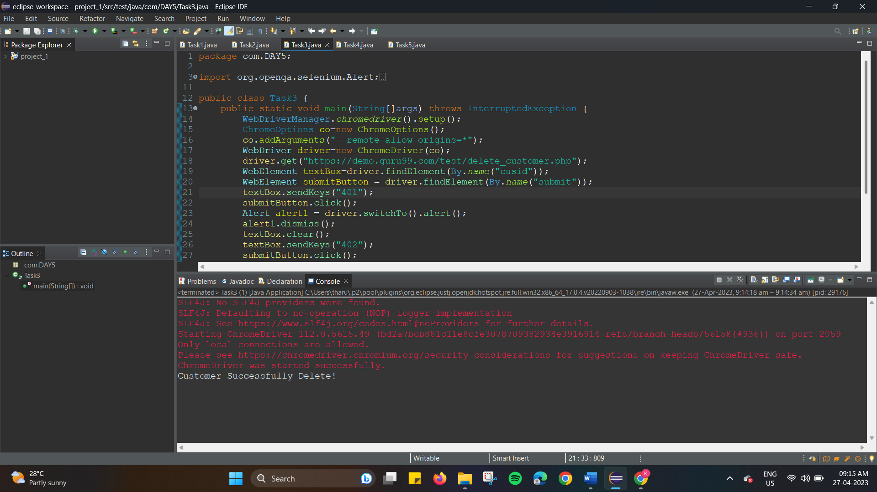

**TASK 4 :**

package com.DAY5;

import org.openqa.selenium.By;

import org.openqa.selenium.JavascriptExecutor;

import org.openqa.selenium.Keys;

import org.openqa.selenium.WebDriver;

import org.openqa.selenium.WebElement;

import org.openqa.selenium.chrome.ChromeDriver;

import org.openqa.selenium.chrome.ChromeOptions;

import io.github.bonigarcia.wdm.WebDriverManager;

public class Task4 {

public static void main(String[]args) throws InterruptedException {

WebDriverManager.chromedriver().setup();

ChromeOptions co=new ChromeOptions();

co.addArguments("--remote-allow-origins=*");

WebDriver driver = new ChromeDriver(co);

driver.manage().window().maximize();

driver.get("https://www.abhibus.com/bus-ticket-booking/");

WebElement Departure = driver.findElement(By.id("source"));

Departure.sendKeys("Coimbatore");

Thread.sleep(500);

Departure.sendKeys(Keys.ENTER);

WebElement Destination= driver.findElement(By.id("destination"));

Destination.sendKeys("Thiruvarur");

Thread.sleep(500);

Destination.sendKeys(Keys.ENTER);

WebElement journeyDate=driver.findElement(By.xpath("//*[@id=\"datepicker1\"]"));

journeyDate.click();

JavascriptExecutor js=(JavascriptExecutor)driver;

js.executeScript("arguments[0].setAttribute('value','04/05/2023')",journeyDate);

WebElement search=driver.findElement(By.xpath("//*[@id=\"seo_search_btn\"]"));

search.click();

}

}

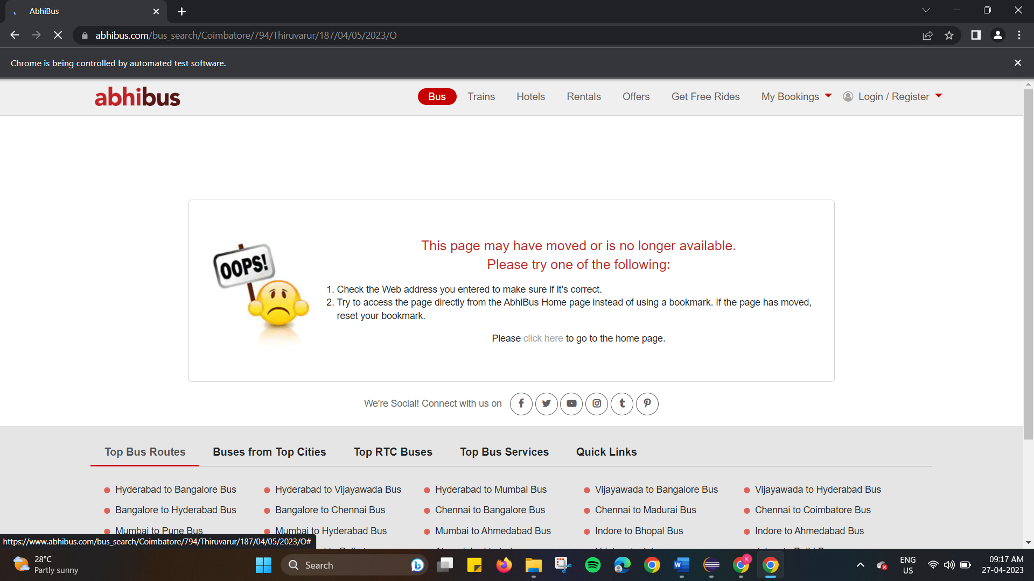

**TASK 5 :**

package com.DAY5;

import java.util.Set;

import org.openqa.selenium.By;

import org.openqa.selenium.Keys;

import org.openqa.selenium.WebDriver;

import org.openqa.selenium.WindowType;

import org.openqa.selenium.chrome.ChromeDriver;

import org.openqa.selenium.chrome.ChromeOptions;

import io.github.bonigarcia.wdm.WebDriverManager;

public class Task5 {

public static void main(String[]args) throws InterruptedException {

WebDriverManager.chromedriver().setup();

ChromeOptions co=new ChromeOptions();

co.addArguments("--remote-allow-origins=*");

WebDriver driver = new ChromeDriver(co);

driver.manage().window().maximize();

driver.get("https://www.google.com/");

driver.findElement(By.name("q")).sendKeys("Apple");

driver.findElement(By.name("q")).sendKeys(Keys.ENTER);

String parent = driver.getWindowHandle();

System.out.println(parent);

System.out.println(driver.getTitle());

driver.switchTo().newWindow(WindowType.TAB);

driver.get("https://www.google.com/");

driver.manage().window().maximize();

driver.findElement(By.name("q")).sendKeys("Selenium");

driver.findElement(By.name("q")).sendKeys(Keys.ENTER);

System.out.print("\n"+driver.getWindowHandle());

System.out.println("\n"+driver.getTitle());

driver.switchTo().newWindow(WindowType.TAB);

driver.get("https://www.google.com/");

driver.manage().window().maximize();

driver.findElement(By.name("q")).sendKeys("Cucumber");

driver.findElement(By.name("q")).sendKeys(Keys.ENTER);

System.out.print("\n"+driver.getWindowHandle());

System.out.println("\n"+driver.getTitle());

Set<String>s = driver.getWindowHandles();

System.out.println("Number of Windows opened="+s.size());

}

}

